INFORMAtION AND COMMUNICATION TECHNOLOGIES (ICT)

A Comparative Analysis of Google Services, Microsoft Tools, Git, and GitHub

January 2, 2024

USTHB UNIVERSITY

2023/2024

# Introduction :

In today's digital age, Information and Communication Technologies (ICT) play a vital role in various aspects of our lives. This report aims to provide an overview and comparative analysis of popular ICT tools and platforms, focusing on Google services, Microsoft tools, Git, and GitHub. By examining their features, benefits, and use cases, we can gain a deeper understanding of how these technologies contribute to our digital experiences and collaborative endeavors.

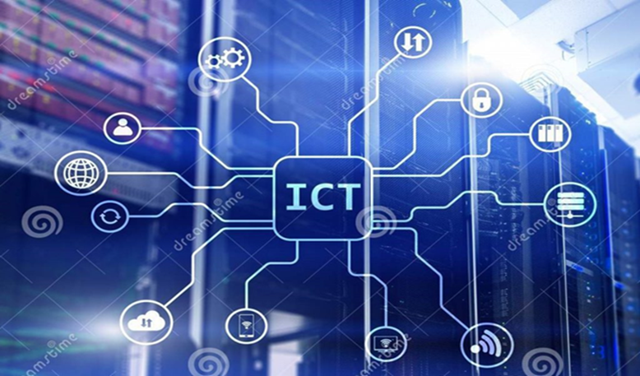

## 1.1. Connectivity :

ICT enables seamless connectivity, allowing individuals and organizations to communicate and collaborate across vast distances. With the advent of high-speed internet, mobile networks, and Wi-Fi, people can stay connected anytime, anywhere.

## 1.2. Communication Tools:

ICT provides a wide range of communication tools that enhance productivity and streamline interactions. Email, instant messaging, video conferencing, and collaboration platforms like Microsoft Teams and Slack have transformed how we communicate and collaborate in real-time.

## 1.3. Data Management:

ICT plays a crucial role in data management. Cloud computing allows for efficient storage, backup, and retrieval of data, eliminating the need for physical storage devices. Big data analytics and machine learning leverage ICT to extract valuable insights from vast amounts of data.

